**Machine Learning, Statistics and Crypto Research Project 1:**

**Calculating Cryptocurrency Beta Using Regression**

While calculating the cost of crypto, it is important for an investor to calculate the beta of the cryptocurrency.

Beta of a publicly exchange traded crypto can be calculated using Regression (Slope).

In this method, we regress the crypto’s returns (ri) against the market’s index returns (rm). The beta (β) is represented by the slope of the regression line.



Where,

ri is the crypto’s return

α represents the intercept

β is the crypto’s beta

rm is the market (index) returns

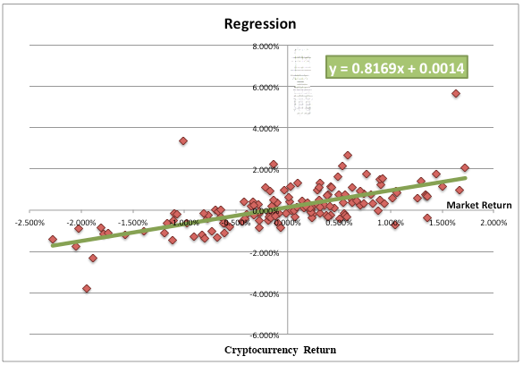

The Beta of a crypto is a measure of the sensitivity of its returns relative to a market benchmark (usually a crypto market index). How sensitive/insensitive is the returns of an asset to the overall market returns (usually a crypto market index like [CCI30](http://www.cryptoindices.io/) index). What happens when the market jumps, does the returns of the asset jump accordingly or jump somehow?

**Interpretation of a Beta result**

A cryptocurrency with a beta of:

zero indicates no correlation with the chosen benchmark (e.g. CCI30 index )

one indicates a crypto has the same volatility as the market

more than one indicates a crypto that’s more volatile than its benchmark

less than one is less volatile than the benchmark

1.5 is 50% more volatile than the benchmark

The beta value of 1.0 is the benchmark against which all crypto betas are measured.

Beta > 1 - aggressive cryptos

These cryptos tend to go up faster then the market in a rising (bull) market and fall more than the market in a declining (bear) market.

Beta < 1 - defensive cryptos

These cryptos will generally experience smaller than average gains in a rising market and smaller than average falls in a declining market.

Beta = 1 - neutral cryptos

These cryptos are expected to follow the market.

**Some of the issues while calculating Beta**

Estimation period: Beta is usually estimated using the historical data for many years, but in case of Cryptos you may do it for months because of the current volatility. The choice of estimation period affects the calculation of Beta. If the estimation period is short, it does reflect the current dynamics of the cyptos. For example, for a crypto that has recently undergone structural changes, it’s better to use short estimation period for calculating beta. However, for a cryptos that has a stable operating history, a long estimation period will be suitable.

Price interval: An investor may take daily, weekly, or monthly prices of the crypto and market while performing regression. Generally a shorter observation period such as daily prices leads to lower standard error. Please note that historical intraday prices (OHLCV) on the hourly and minute time frames are also available.

**Our Assignment is to calculate the Beta of** [**Bitcoin**](https://www.coinbase.com/charts?locale=en) **and** [**Ethereum**](https://www.coindesk.com/ethereum-price/)**.**

**Step One: Get Bitcoin and Ethereum Price Data**

Once you have decided on the Estimation period and Price Interval the first step is to get the historical prices. There are a lot of sources to get historic data for crypto prices:

<https://www.quora.com/Where-can-I-get-historical-raw-data-on-Bitcoin-price-and-volume-across-different-exchanges>

<https://bitcoin.stackexchange.com/questions/36088/where-can-i-find-historical-price-of-altcoins>

<https://coinmetrics.io/data-downloads/>

You can also download the price data using Python:

<http://blockxchain.org/2017/09/05/getting-started-with-the-cryptocompare-api-in-python/>

<https://medium.com/@agalea91/cryptocompare-api-quick-start-guide-ca4430a484d4>

**Step Two: Download Index Data**

You can use any Crypto index there are a few indexes available, like:

<https://www.crypto30.com/index/>

<https://cci30.com/>

<http://www.cryptoindices.io/>

<http://crix.hu-berlin.de/>

You can download most of the Index data, for example:

[Download the CCI20 daily values of the index (.csv)](https://cci30.com/ajax/getIndexHistory.php)

The API to get CryptoIndices data is here:

<http://www.cryptoindices.io/Pages/api/16>

**Step Three: Clean and Pair the Data**

Assuming that you have chosen to use interday prices you have to make sure that the price of the Bitcoin, Ethereum and Index are compatible i.e. have the same estimation period and price interval.

**Step Four: Calculate the Returns for the index**

Lets first calculate the return of crypto indices. To calculate the return of a crypto index any two points in time, follow these steps:

First, find the price level of the chosen index on the first and last trading days of the period you're evaluating. Be sure to use the opening price on the first day and the closing price on the last in order to make sure your calculation is as accurate as possible. If you are doing for a day then just use the ending price of yesterday as starting price, and closing price of today as ending price.

Next, subtract the starting price from the ending price to determine the index's change during the time period.

Finally, divide the index's change by the starting price, and multiply by 100 to express the index's return as a percentage.

Putting the formula together, we have:

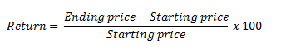

An example

Let's say that you want to calculate the return of the crypto index during the month of October 2, 2017.

First, using an accurate price, determine the starting and ending price. In this case, on October 1, the index closed at 1,919.65 and on October 2, the index closed at 2,079.36.

Using the formula mentioned above, we can see that the return on October is:

October 2 Return = ((2,079.36 – 1,919.65) / 1,919.65) x 100 = 8.3%

A positive percentage indicates that the index increased during the time period, while a negative percentage indicates that the index fell. So, during October 2, the index increased in value by 8.3%.

**Step Five: Calculate the Returns for the Cryptos**

What you have done for the index in step four, calculate the returns for Bitcoin and Ethereum.

**Step Six: Regression Analysis**

Now you have returns for the index, Bitcoin and Ethereum.

First, we will do regression on Bitcoin. There are two variables involved, the return on Bitcoin and the return on the index. The return on index is on the X-axis and the return on the Crypto (Bitcoin) is on the Y-axis. The slope of the regression line is the Beta of Bitcoin. Also draw the regression line as shown above.

Now you do the same thing with Ethereum,

Now the graph will show two regression lines, one for Bitcoin and one for Ethereum.

Requirements:

1. Estimate the Bitcoin and Ethereum Beta’s using only Python StatsModel

<http://www.statsmodels.org/stable/regression.html>

Example: <https://medium.com/python-data/capm-analysis-calculating-stock-beta-as-a-regression-in-python-c82d189db536>

1. Estimate the Bitcoin and Ethereum Beta’s using TensorFlow.

Learning Regression:

<https://www.youtube.com/watch?v=zPG4NjIkCjc>

<https://www.youtube.com/watch?v=ZkjP5RJLQF4>